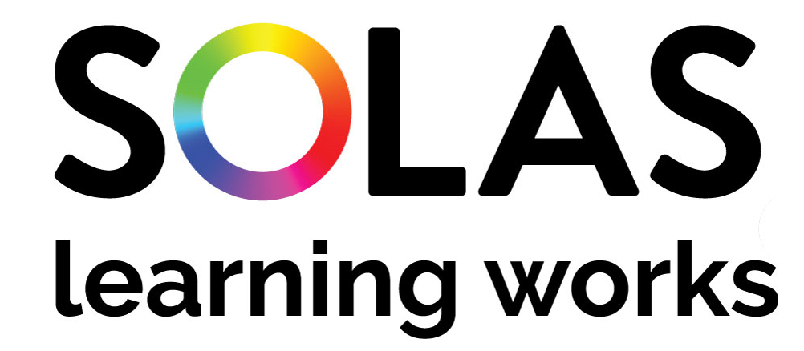
Director
Branding, Communications & Strategy Implementation

Title: Director: Branding, Communications & Strategy Implementation (Grade 4)

Reporting to: Executive Director, Transformation

Office: SOLAS

Location: Block 1, Castleforbes House, Castleforbes Road, Dublin 1.

Tenure: Permanent
Reference: 274

Background:
SOLAS (An tSeirbhís Oideachais Leanúnaigh agus Scileanna), the Further Education and Training Authority of Ireland was established on 27 October 2013. Its mission is to fund, co-ordinate and monitor a range of Further Education and Training (FET) provision to support economic and social wellbeing, while simultaneously playing its part in influencing and supporting the development of a FET sector that is more responsive to the needs of learners and employers. Set out in the Education and Training Act, 2013, the general functions of SOLAS are to:

- prepare and submit to Minister a strategy in respect of the provision of further education and training;
- promote an appreciation of the value of further education and training provision;
- consult with Ministers for Department of Employment Affairs and Social Protection (DEASP) and Department of Business, Enterprise and Innovation (DEBI), as relevant, to ascertain priorities as to which further education and training programmes should be the subject of grants;
- fund Education and Training Board (ETBs) and other bodies engaged in the provision of further education and training;
- provide, arrange and coordinate training and re-training for employment;
- promote, encourage and facilitate the placement of persons belonging to designated social welfare categories, as set-out by the Minister for Employment Affairs and Social Protection;
- promote cooperation between ETBs and other bodies involved in the provision of further education and training;
- promote equality of opportunity within further education and training;
- develop and facilitate new and existing further education and training programmes, including the design of systems to monitor the quality of the provision; ensuring that it is fit for purpose;
- conduct or contract relevant research;
- provide or assist in the provision of training to persons charged with the delivery of further education and training (CPD).

See http://www.irishstatutebook.ie/2013/en/act/pub/0025/index.html for the full text of the Act.

SOLAS is an agency of the newly formed Department of Higher Education, Innovation and Science. It works in close collaboration with Education and Training Boards (ETBs) on provision of high-quality further education and training, equipping learners with relevant skills and knowledge, providing a pipeline of talent into employment and to the Irish economy and society. Working with sister agencies, SOLAS leads actions in key policy and strategy documents including the most recent Further Education and Training (FET) Strategy 2020 – 2024, the evaluation of the National Youthreach Programmes (2019), the National Skills Strategy 2025 and others.

The Role:
The Branding, Communications and Strategy Implementation Director will be an integral part of the senior leadership team, reporting directly to the Executive Director, Transformation. The Transformation Division is responsible for the implementation of the Future of FET, using strong evidence-based strategies, performance management, stakeholder influence and clear communications to drive required change in further education and training.

The successful candidate will play a major role in the implementation of the SOLAS FET Strategy, the delivery of a project management office approach (PMO) in SOLAS, a supporting role in the development of the FET College of the Future and raising the profile of FET through effective branding and communication strategies and campaigns. This role also acts as secretariat to the SOLAS Board.

S/he will be an innovative individual with leadership experience in a complex organisation, with the capacity to influence change across the FET system, lead the development and establishment of high quality branding, communication and implementation approaches, as the FET sector grows its contribution to Ireland’s economic and social well-being. S/he will also possess the technical and personal competencies required to lead, manage and support people and brand change in an organisational context.

This role will offer a unique opportunity to be part of the senior team in an established Public Service Agency with a substantial sphere of influence across the FET sector and within further education and training provision in Ireland. SOLAS is an agency with substantial accountability in educational funding and a remit to help develop the knowledge and skills necessary to meet national and global economic challenges.

Key Responsibilities:
The Director will have senior leadership accountability and management responsibility for FET branding, internal and external communications, Board secretariat, FET strategy implementation using a PMO approach and a clear focus on the future of FET.

S/he

- Provide leadership and management of an integrated high performance team
- Effectively manage and support external implementation groups and internal network groups focused on FET strategic objectives
- Act as Secretariat and liaison with the SOLAS Board, support its effective operation and ensure that exemplary standards of corporate governance are maintained for compliance related to legislative requirements.
- Contribute to the success of the senior leadership team by embedding a strong peer network, reflecting the values of SOLAS
- Oversee all corporate communications and internal communication strategies effectively, including the coordination of the public affairs work of SOLAS and the Freedom of Information (FOI) process
- Plan, coordinate and deliver strategic communications campaigns, events and resources that supports the achievement of SOLAS’ objectives, raise the profile of FET and reinforce the effective delivery of the SOLAS FET Strategy
- Develop and implement a PMO based approach in SOLAS and manage a multi stakeholder process to ensure the effective development and delivery of the FET strategy implementation plan
- Lead the development of the FET College of the Future and the transformation required across the FET system to facilitate this
- Achieve outcomes and deliverables assigned, including FET Strategy Implementation Plan, the Strategy PMO Approach and the FET College of the Future.

The Individual:
The successful candidate will have:
- Extensive senior management experience and demonstrated achievement in a complex delivery environment indicating delivery of change and operational planning.
- Demonstrated achievement in the management of a variant and diversified portfolio in a devolved management structure.
- Proven experience in a significant communications role at a senior level. This includes excellent written and spoken communication skills, as well as a working familiarity with information technology.
- Ability in relating effectively with a diverse range of people internal and external to the organisation, including government departments, Board members and staff representatives.
- Demonstrate an ability to take a system-wide approach and see connections, risk, and the potential for innovation in the wider environment.
- Broad understanding of continuous development, innovation and achievement of results against objectives in career to date.
- Knowledge of data governance practices and technology issues, regulatory requirements and emerging trends and issues.
- Exemplary public service values including the highest standard of professional integrity and operating with probity.
- Self-starter attributes possessing the necessary drive and resilience.
- A record of academic achievement that will include a relevant primary degree, or equivalent, at a minimum.

Principal Conditions of Service:

Probation
A probationary period of nine months applies to this role.

Remuneration
The rate of total remuneration for the post of Director (Grade 4) (effective 1st September 2019) is as follows: is as follows:

Personal Pension Contribution (PPC) rate:
The Grade 4 pay scale (PPC) is €87,325 to €107,399

Candidates should note that the entry point will be at the minimum (1st point) of the relevant scale and the rate of remuneration may be adjusted from time to time in line with Government pay policy.

This rate will apply where the appointee is newly recruited to the civil or public service or is an existing civil or public servant appointed on or after 6th April 1995 and is required to make a personal pension contribution.

A different rate may apply where the appointee is a civil or public servant recruited before 6th April 1995 and who is not required to make a personal pension contribution.

Tenure
This appointment is a permanent position.

Location
The headquarters of SOLAS are currently based in Castleforbes House, Dublin 1.

Hours of Attendance
Working hours will be in accordance with the standard arrangements for SOLAS, however flexible working arrangements may be considered.

Annual Leave
The annual leave allowance will be 30 working days a year. This allowance is subject to the usual conditions regarding the granting of annual leave and it is based on a five-day week and is exclusive of the usual public holidays.

Superannuation and Retirement
The successful candidate will be offered the appropriate superannuation terms and conditions as prevailing in the Public Service, at the time of being offered an appointment. Pensionable public servants (new joiners) recruited on or after 1 January 2013 will be members of the Single Public Service Pension Scheme (Single Scheme). Please note that the Single Scheme applies to all pensionable first time entrants to the public service, as well as to former public servants returning to the Public Service after a break of more than 26 weeks. In certain circumstances, the 26-week rule does not apply. The legislation giving effect to this scheme is the Public Service Pensions (Single Scheme and Other Provisions) Act 2012. For further information in relation to the Single Public Service Pension Scheme for Public Servants please see the following website: http://www.per.gov.ie/pensions

Key Competencies for effective performance:
The attention of candidates is drawn to the key competencies that are used for posts at this level.
This competency model reflects the changing and more complex environment in which those at this level operate, with fewer resources, pressure for delivery of results, increased media and public scrutiny and an ambitious public service reform programme.

Effective Performance Indicators

Leadership  & Strategic  Direction | Leads the team, setting high standards, tackling any performance problems & facilitating high performance
 | Facilitates an open exchange of ideas and fosters an atmosphere of open communication
 | Contributes to the shaping of organisational strategy and policy
 | Develops capability and capacity across the team through effective delegation
 | Develops a culture of learning & development, offering coaching and constructive / supportive feedback
 | Leads on preparing for and implementing significant change and reform
 | Anticipates and responds quickly to developments in the organisation / broader environment
 | Actively collaborates cross-functionally in SOLAS and with other organisations and Agencies
Judgment &  Decision Making | Identifies and focuses on core issues when dealing with complex information/ situations
 | Assembles facts, manipulates verbal and numerical information and thinks through issues logically
 | Sees the relationships between issues and quickly grasp the high level implications
 | Identifies coherent solutions to complex issues
 | Takes action, making decisions in a timely manner and having the courage to see them through
 | Makes sound and well informed decisions, understanding their impact and implications
Management  & Delivery of  Results | Initiates and takes personal responsibility for delivering results/ services in own area
 | Balances strategy and operational detail to meet business needs
 | Manages multiple agendas and tasks and reallocates resources to manage changes in focus
 | Makes optimum use of resources and implements performance measures to deliver on objectives
 | Ensures the optimal use of ICT and new delivery models
 | Critically reviews projects and activities to ensure their effectiveness and that they meet Organisational requirements
 | Instils the importance of efficiencies, value for money and meeting corporate governance requirements
 | Ensures team are focused and act on Business plans priorities, even when faced with pressure
Building  Relationships &  Communication | Speaks and writes in a clear, articulate and impactful manner
 | Actively listens, seeking to understand the perspective and position of others
 | Manages and resolves conflicts / disagreements in a positive & constructive manner
 | Recognises & manages tensions arising from different stakeholders perspectives
 | Persuades others; builds consensus, gains co-operation from others to obtain information and accomplish goals
 | Proactively engages with colleagues at all levels of the organisation and across other Organisations / Agencies and builds strong professional networks
 | Makes opinions known when s/he feels it is right to do so
Specialist  Knowledge,  Expertise and Self  Development | Develops and maintains skills and expertise across a number of areas that are relevant to his/her field and is recognised by people internal and external to the organisation
 | Keeps up to date with key sectoral, national and international policies and economic, political and social trends that affect the role
 | Maintains a strong focus on self-development, seeking feedback and opportunities for growth
Drive &  Commitment to  SOLAS  Values | Consistently strives to perform at a high level
 | Demonstrates personal commitment to the role, maintaining determination and persistence while maintain maintains a sense of balance and perspective in relation to work issues
 | Contributes positively to the corporate agenda
 | Is personally trustworthy, honest and respectful, delivering on promises and commitments
 | Ensures the learner is at the heart of all services provided
 | Is resilient, maintaining composure even in adverse or challenging situations
 | Promotes a culture that fosters the highest standards of ethics and integrity

